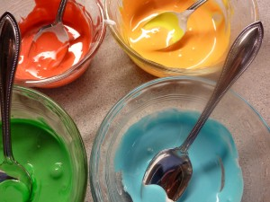
LESSON #2

Title of unit: Exploring Emotion Through Art
Title of lesson: Creative Color Mixing
Cycle/Grade: Grades 5-6 (With minor adjustments, the unit could be adapted to the younger grades as well).

Rationale: The purpose of this lesson is to introduce the concept of color mixing in a hands-on, non-traditional way. This lesson will allow students to explore color and develop a meaningful understanding of primary, secondary and tertiary colors, which they will be able to put to use when producing individual works of art. The big idea that three main colors can be mixed together in various pairings and quantities to make a range of beautiful colors will be explored. This lesson is also intended to allow the students to come to the realization that non-traditional tools and materials can be used to create art and that we should not limit ourselves to the traditional methods, but rather think outside the box to create personalized, unique works or art.

Logistics:

Prior
- Buy or make white icing (1 small tub is enough for one group of 4 students).
- Buy yellow, red and blue food coloring
- Buy or make shortbread cookies (12 per student)

Other materials needed
- Large sheets of white paper (1 per group needed)
- Regular sized sheets of white paper (1 for each student)
- Markers
- Camera
- A bunch of plastic spoons
- A bunch of small plastic plates or bowls
- Rulers
- Paint brushes and red, yellow, blue, black, and white paint
- Pallets
- Cups for water
- Painting paper

Specific objectives:
By the end of this lesson, students will be able to:
- State the three primary colors
- Mix the three primary colors in different pairings and quantities to make secondary and tertiary colors.
- Create their own color wheel
- Know how to refer to their color wheel to make colors in the future
- State and use various traditional and non-traditional art tools and materials
- Define the importance of using non-traditional tools/materials
- Create their own unique painting to express and explore emotion\

Introduction Activity/Motivation: [30-45 minutes]
(keep up the art painting from last class)
- The middle table will hold icing, cookies, food coloring, bowls, spoons, markers, and all the white paper.
- The students will be put into groups of 4 and will appoint 1 material organizer.
- The teacher will tell the students that they will be exploring how to mix colors using icing and food coloring.
- The teacher will ask the students if anyone knows what a color wheel is and what it represents (if no one knows, explain).
- The students will be told that, in groups, they will create a group color wheel and then create individual color wheels, using cookies that they will document, by taking a picture of each of them so that they can make reference to them when mixing colors in the future (make sure you let the students know that they will be able to eat their cookies, BUT only after their work has been documented).
- Have the material organizer, from each group, come up to collect a large white paper, ruler, and 2 different colored markers.
- Instruct the students to create one large equilateral triangle on their sheet. Then have them draw a second equilateral triangle in the other direction, using a different colored marker to create a star.
- Have the material organizer come back up to the materials desk to collect 12 bowls or plates, 12 spoons, a tub of icing, and blue, yellow and red food coloring.
- 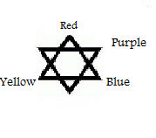Tell the students to fill 3 bowls with icing and create blue, yellow and red icing. Have them place these bowls in the three corners of one of the triangles.
- To make the secondary colors, which will go on the corners of the other three points, have them mix the two colors that are on either side of each point (refer to picture).
- Next have them make the tertiary colors by mixing two of the secondary colors.
- Once all of this is done they may begin icing their cookies and arranging them in a circle, referring to the big diagram they have just made. Document each of these.
Discussion questions for critical thinking and to check for comprehension
(During these questions students can eat their cookies)
  - From this activity, what have you discovered are the three primary colors?
  - What was the purpose of the triangles? Why did I have you draw them?
  - Why did we document these? How will your picture help you in other art classes?
  - Why do we call them secondary and tertiary colors?

- Clean up: Have one student, from each group, throw out all the garbage from their area and have another student bring the reusable materials back up to the middle table.

Activity: [25 minutes]

- The teacher will tell the students to use their Polaroid’s or quick print pictures of their color wheel as a reference for this activity.
- The teacher will tell the students pick one of the hanging artworks that were discussed last class, which they enjoy.
- The students will take down the painting and then collect a paintbrush, water cup, pallet, a piece of painting paper, and any tools they see on the table which seem interesting to them.
- The teacher will tell the students that they are to experiment making the colors found in the artists painting and create their own painting keeping an emotion in mind. Tell the students that they are to use and experiment with various tools (paintbrush, sponges, Popsicle sticks, string, toothbrush, fingers, various other tools).

Conclusion: [10 minutes]
Clean up: Have 5 students, at a time, quickly wash their brushes and pallets, while all others are putting their paintings on the ledge to dry. Send 5 more until everyone is done.
- The teacher will tell the students to put away their color wheel picture in their art box so that they can refer to it on a regular basis.
- End of lesson discussion questions:
  - What did you enjoy about this lesson and how will it help you in our future art classes?
  - What are some traditional and non-traditional tools and materials explored today? What are the benefits of using non-traditional tools?
  - How did your new knowledge behind mixing colors help you when exploring the colors from one of the artist’s paintings?

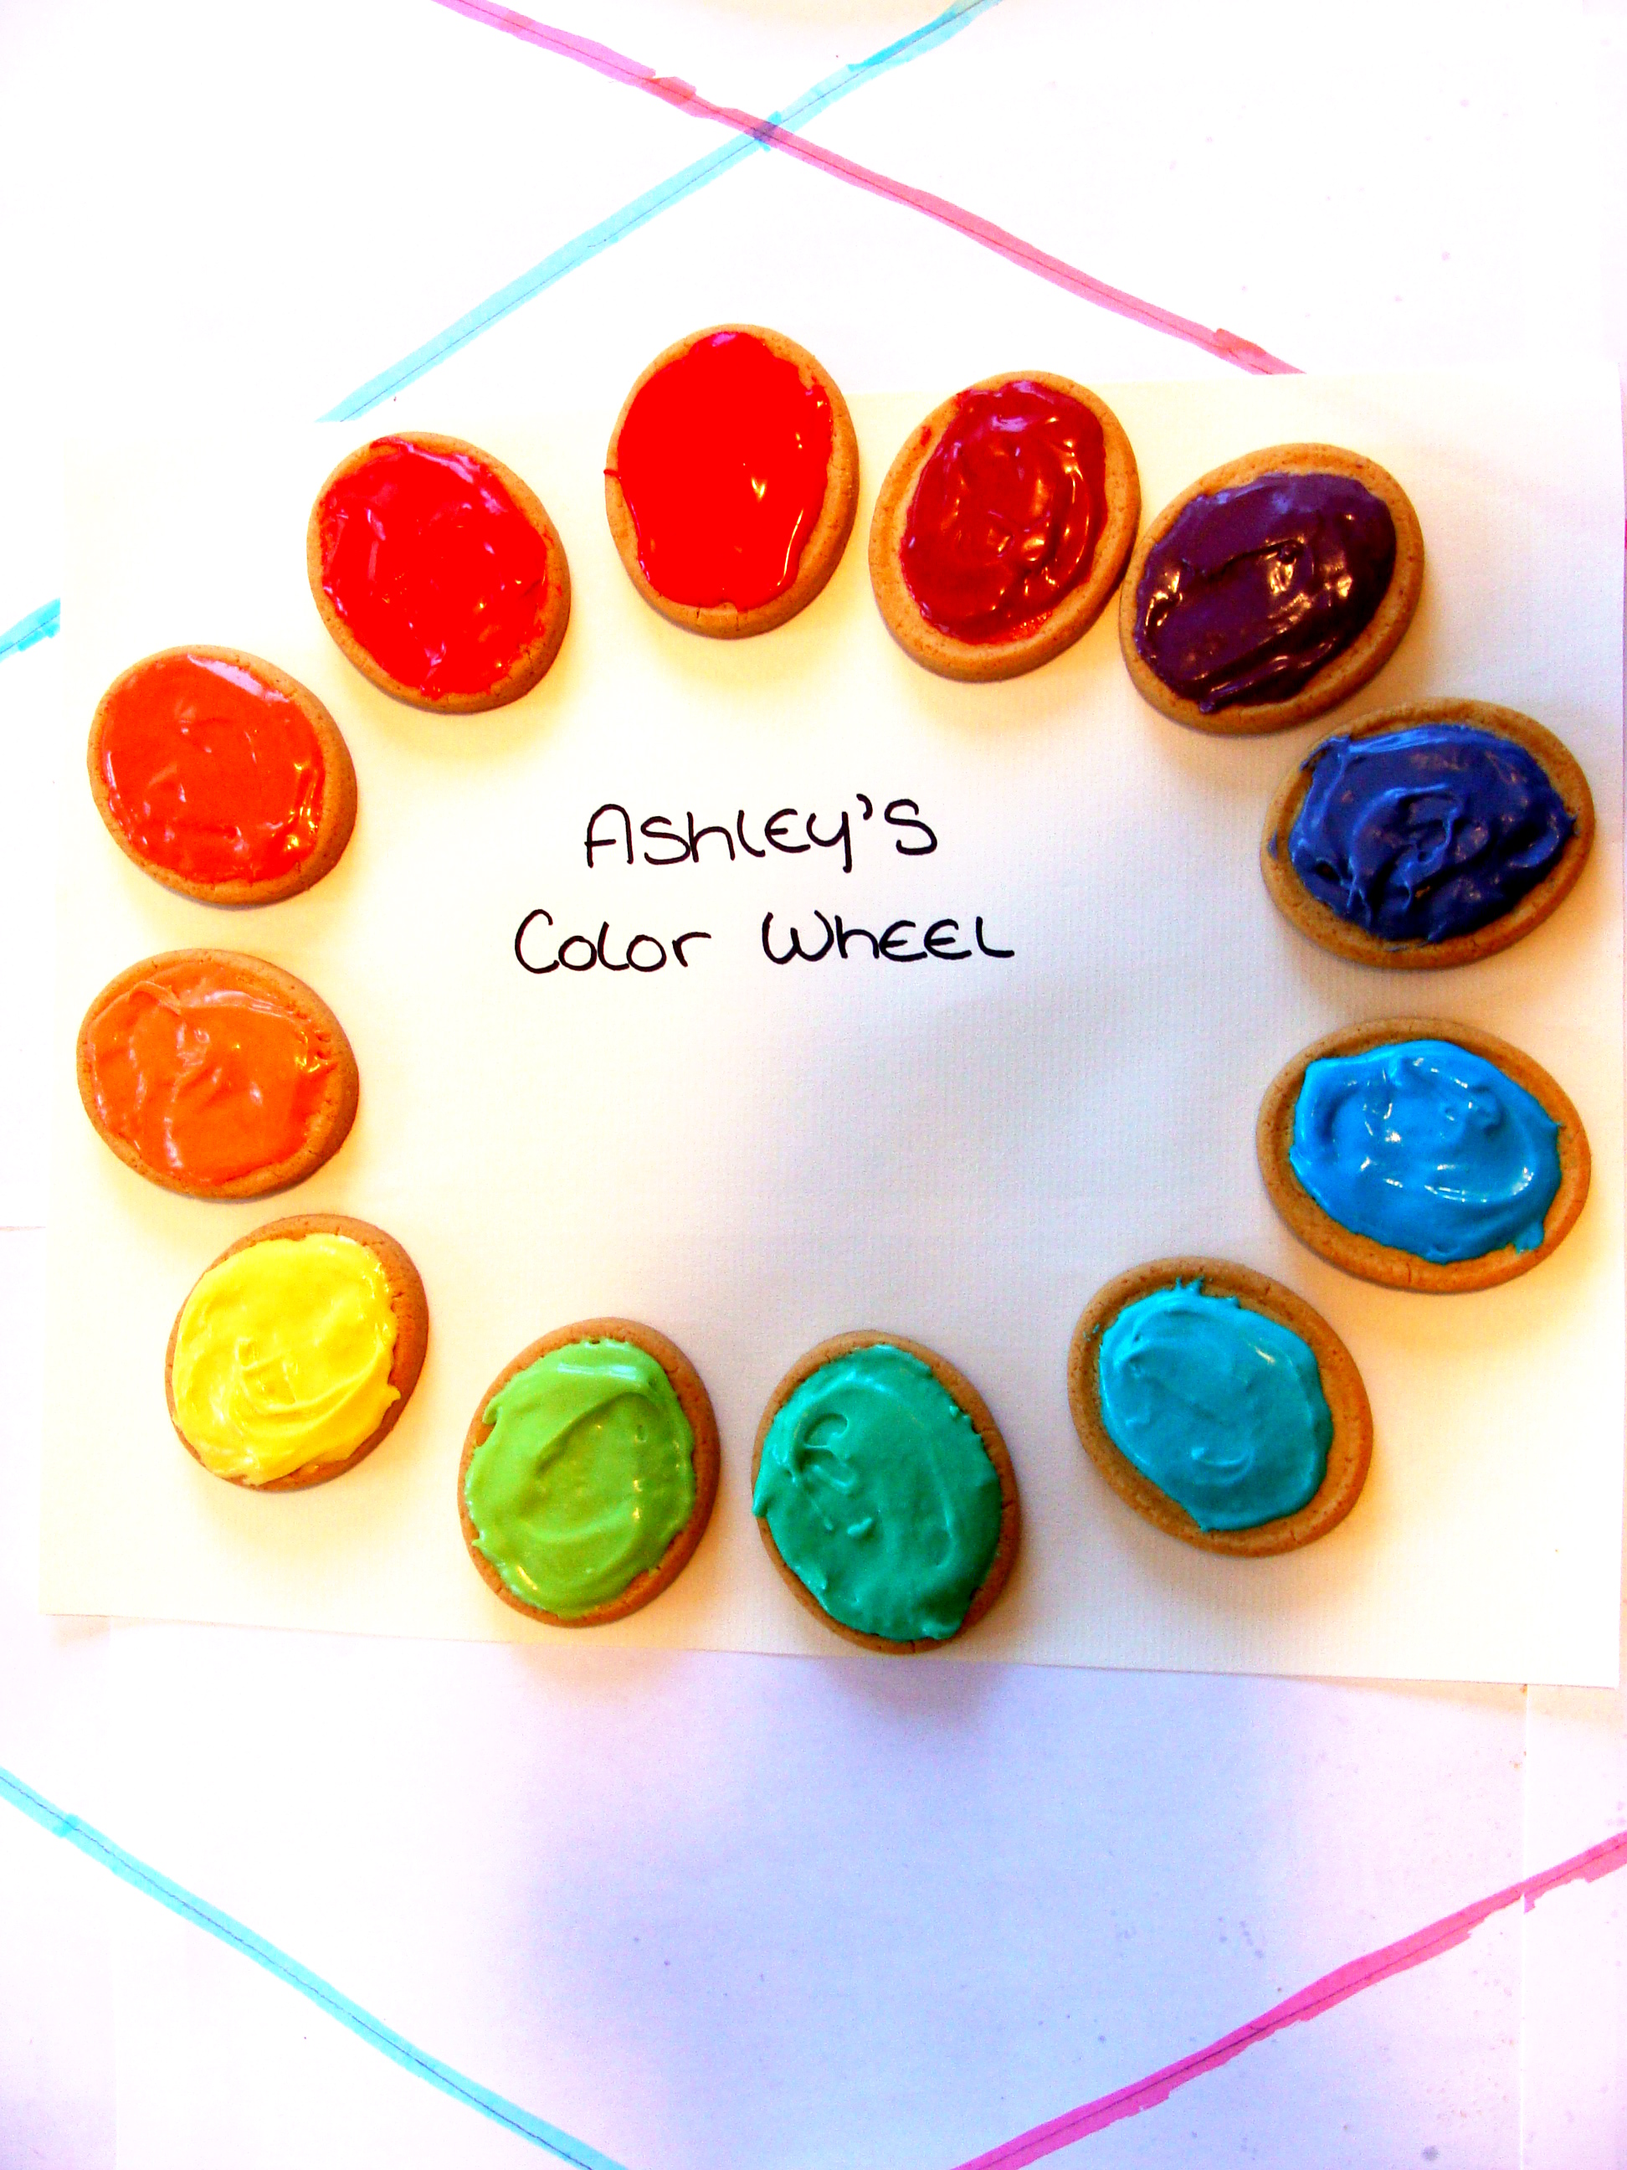
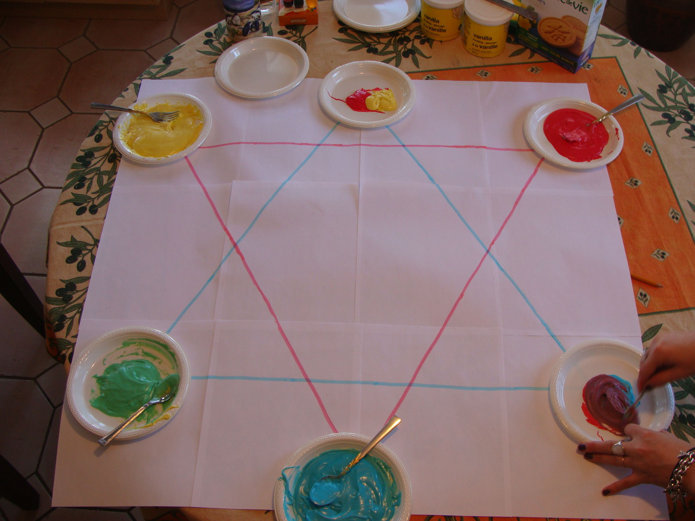

Resources: http://www.mabelwhite.com/FrenchVersion/EdibleColorWheel.pdf

